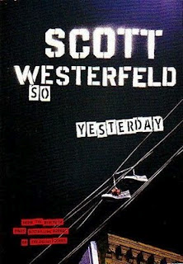[](http://sarahdessen.com/book/just-listen/)[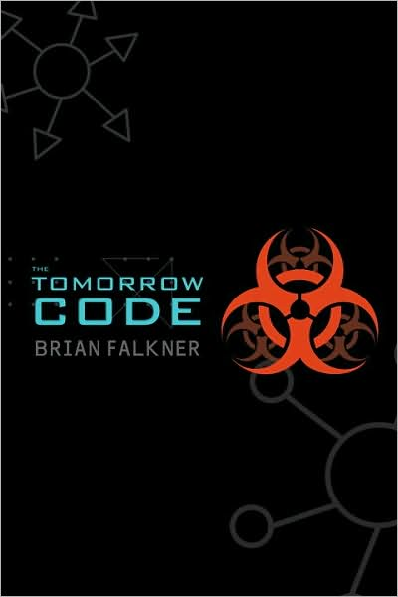](https://youtu.be/hasAUqFbdcw)[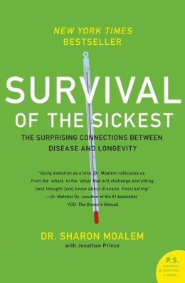](http://www.nbcnews.com/video/today-show-health/17023771%2317023771)[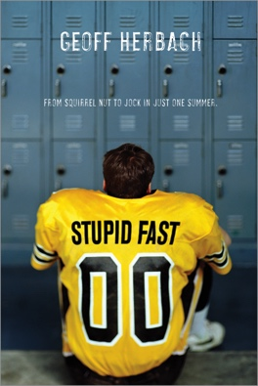](http://www.audible.com/pd/Teens/Stupid-Fast-Audiobook/B005ZUHZGW)[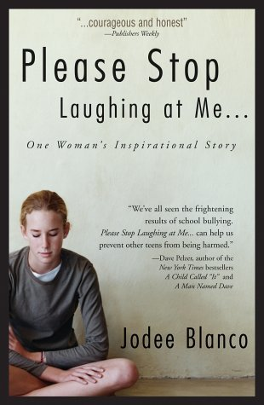](https://youtu.be/H2HjMHh-QUM?t=31)

ENTERING 9TH

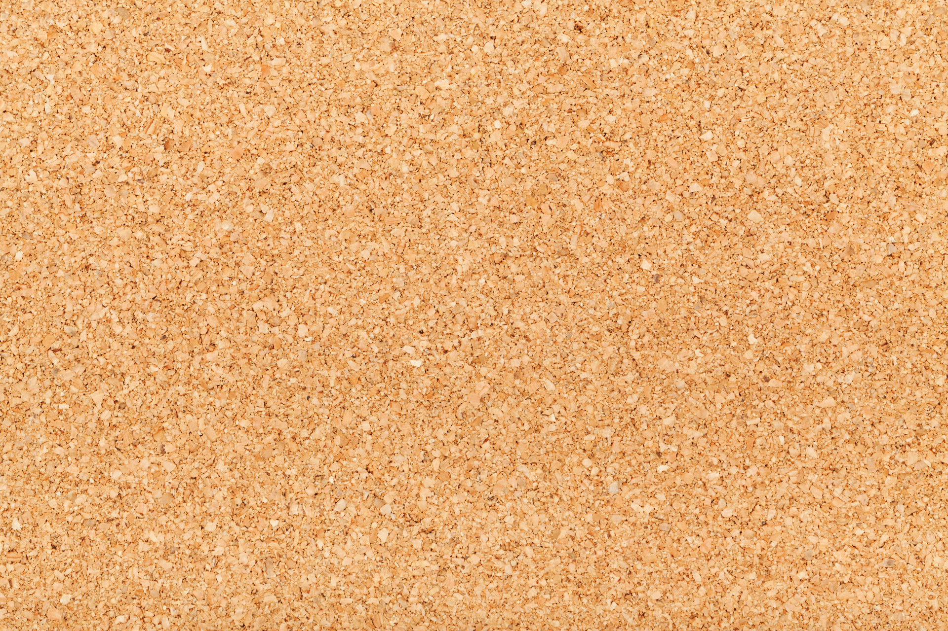

ENTERING 10TH

[](https://youtu.be/6JPFzy0hJeo)

[](https://youtu.be/9NmOirJ6wuk)[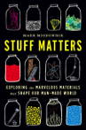](https://youtu.be/zCzLDIn5VGM)

[](https://youtu.be/QgAJDjH5EA)[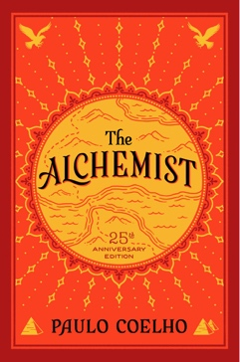](https://youtu.be/tLNadHuYPTU)

ENTERING 11TH

[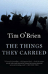](https://www.brillianceaudio.com/product?i=4935)[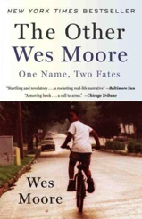](https://youtu.be/udQWOfALwj4)

[](https://youtu.be/Ge6oVjM6M8M)

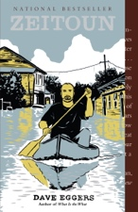[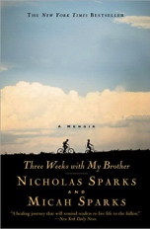](http://nicholassparks.com/stories/three-weeks-with-my-brother/)

[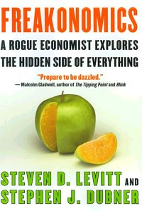](https://youtu.be/h1YjkXGxbT0)

[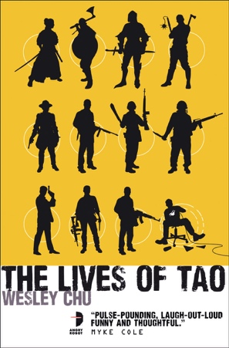](http://www.audiobooks.com/audiobook/lives-of-tao/172732)

[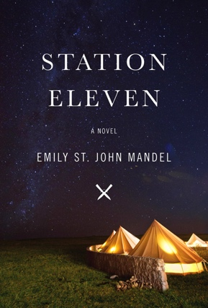](https://youtu.be/osXRdUeXCHE)[](https://youtu.be/9D4g0k3E7Q4?t=57)[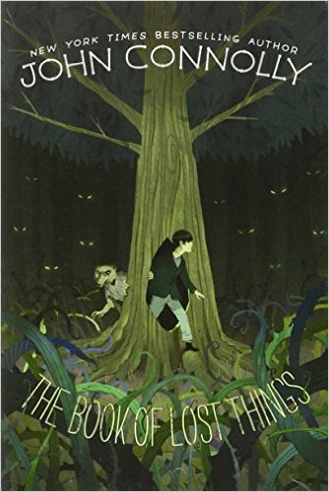](http://www.johnconnollybooks.com/novels_lost_chap.php)

ENTERING 12TH